***MINUTES***

***Bluewater Wood Alliance***

**Board Meeting**

Minutes

Location: Zoom Meeting

Date: December 17 2020

Time: 11:00 am-1:00 pm

**Board Members Present**: Chris Martin, Bill Goethals, Ryan Meade, Scott Burton, Mark Corker, Chuck Pelletier, Amanda McQueen, Laverne Martin, Simon Pett, Nelio Fernandes

**Regrets**: Dennis McGlynn, Jon Wilms, Will Holsappel

**Also attending:** BWA Executive Director, Mike Baker; Blair Tullis, and Peter DeGelder from COGS.

**1. Opening of Meeting/Opening Comments.**

Chris Martin called the meeting to order and welcomed everyone to the meeting. Chris made reference to recent events this year with the BWA adapting to the changes brought about by the Covid19 pandemic. Chris also acknowledged the engaged board of directors and staff that has helped to keep the BWA moving forward.

**2. Approval of the Agenda.**

Mike Baker provided overview of agenda. **Motion to approve agenda without amendments was made by Amanda McQueen, and 2nd by Laverne Martin and carried.**

**3. Approval of Minutes from Previous Board Meeting.**

Minutes from the October 7, 2020 board meeting were distributed prior to the meeting. **Motion to approve minutes was made by Ryan Meade, and 2nd by Scott Burton, and carried.**

**4. Finance Committee Report: Current Quarter**

**The finance committee met on Dec 14 to review the current financials. It was noted to the board that the membership revenue losses expected by the Covid19 pandemic did not materialize. Current actuals show financials trending 11k surplus, and could grow another 20k by year end if all memberships are renewed. No other anomalies were observed in the financials o report.**

**Motion to approve the current quarterly financials was made by Bill Goethals and 2nd by Laverne Martin and carried**

**5. BWA Buying Group Update and Next Steps**

**The BWA Buying Group committee has met regularly since October to move the project forward. Recent change was the third party 4CB group dropping out from being the facilitator of the group. Recent developments include the adoption of a new model to move forward involving another third party buying group facilitator Peter DeGelder from COGS, in tandem with MTech Hub to provide digital infrastructure. Model also includes the BWA to set up a separate “cooperative corporation” to house the group with its own by-laws that include BWA as a designated shareholder. Diagram of the draft model shown below. Reference to BWA shares is really referring to how does BWA retain control; this can be articulated in by-laws vs shares:**

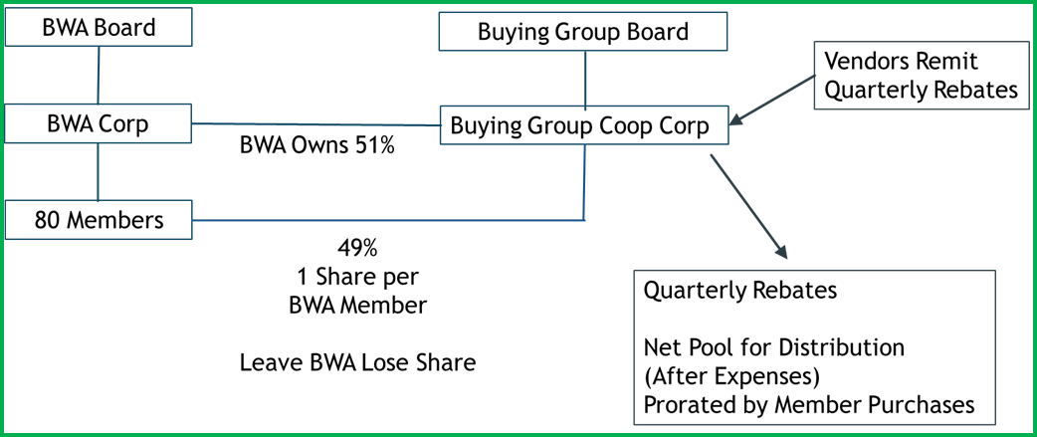

**Many details of the legal definitions of shares and costs remain to be worked out. Legal counsel is required to define the relationship between the BWA and the buying group corp. to ensure BWA maintains control of the group, but is inclusionary enough to deliver value.**

**A pro-forma spreadsheet of costs and potential revenues was presented and discussed by Mark Corker (see separate doc). Costs were identified as COGS management, legal, digital infrastructure, BWA revenue stream, and rebates. Benefits were illustrated over time with increase purchasing thresholds. Funding mechanism included a “loan” from the BWA to get the project moving with payback schedule included in the calculations. A loan from the BWA to finance the group over 9 months was approximately $60k.**

**After much discussion, the board has decided to move forward with the buying group and tabled the following motion:**

**That the BWA hire COGS to proceed with the process of setting up the buying group effective January 1, 2021 by first identifying immediate opportunities with suppliers for rebates to kick start the group, while also identifying timing necessary legal and logistical steps for the establishment of the corp. Investment on the part of the BWA to consist of a max investment of 20k initially with a stop-gate of April 1, 2021 to verify progress warranting further investment moving forward.**

**Motion made by Bill Goethals, 2nd by Chris Martin and carried.**

**6. BWA Digital Transformation Project/ Branding Review**

The BWA branding exercise was reflected upon as a very positive experience for the BWA.

Board members agreed that the final version of the logo was acceptable.

Decision was made to move forward with the re-branding process with both the logo and the name change to Wood Manufacturing Cluster of Ontario.

**Action Item: Mike Baker will be reaching out to Candybox Marketing to consult on next steps and roll-out strategy for the brand and report back to the board.**

**7. Cluster update and funding initiatives**

A detailed document report was prepared by Mike Baker was distributed to the board prior to the meeting for review. A high level review discussed current membership numbers and current initiatives.

The board agreed that this was a good format to keep everyone updated. Refer to this document for details.

**8. 5 yr Strategic Plan/Other Board Business**

Chris Martin presented the idea to the board to conduct a 5 year strategic planning process in 2021.

Because of Covid19 restrictions, much discussion was shared on method (venue- virtual or face-to-face) and timing, and whom to use as a third party facilitator.

Possible names were shared, and third party will be consulted on best timing and method.

**Action Item: Mike Baker will reach out to possible third party facilitators and report back to the board with possible timing**

**9. Motion to adjourn: made by Chuck Pelletier 2nd by Amanda McQueen, and carried.**

**Next BWA Board meeting: TBD March 2021**